**Gold Bridge**

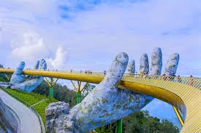 The Gold Bridge (Vietnamese: Cầu Vàng) is a 150-metre-long (490 ft) pedestrian bridge in the Bà Nà Hills resort, near Da Nang, Vietnam. It is designed to connect the cable car station with the gardens (avoiding a steep incline) and to provide a scenic overlook and tourist attraction. The bridge loops nearly back around to itself, and has two giant stone hands designed to appear to support the structure.

**Made by**

The client for the project was the Sun Group. The bridge was designed by TA Landscape Architecture (under Ho Chi Minh City University of Architecture) based in Ho Chi Minh City. The company's founder, Vu Viet Anh, was the principal designer. The bridge opened in June 2018.